PYTHON PROGRAMMING
CASE STUDY ASSIGNMENT
ATM TRANSACTION SEQUENCE SIMULATION
Submitted by: DUDEKULA SUBHAN
Roll Number: 26000893
Branch: CSE – Artificial Intelligence and Machine Learning
College: Dr. RVR & Dr. S. R. NRI Institute of Technology
Academic Year: 2026–2027

1. Problem Statement
An ATM (Automated Teller Machine) allows users to perform basic banking transactions such as depositing and withdrawing money. This project simulates a sequence of ATM transactions using Python. The program maintains the account balance, accepts multiple transactions, validates transaction amounts, rejects withdrawals when the available balance is insufficient, and records transaction details. Finally, it displays the transaction history and the initial and final account balances.

2. Objectives
The main objectives of the ATM Transaction Sequence Simulation are:
- To simulate basic ATM transactions such as deposits and withdrawals.
- To maintain and update the account balance after each successful transaction.
- To validate transaction amounts and reject invalid amounts.
- To prevent withdrawals when the available balance is insufficient.
- To allow users to perform multiple transactions in a single session.
- To store transaction details, including the transaction type, amount, and status.
- To display the transaction history, initial balance, and final balance.

3. Assumptions
The following assumptions are considered in this ATM simulation:
- The initial account balance is ₹1000.
- The user can perform deposits and withdrawals in a single session.
- The transaction amount must be greater than zero.
- A withdrawal is successful only when the requested amount does not exceed the available balance.
- Only the transaction types deposit and withdrawal are accepted.
- The program continues accepting transactions until the user enters no.
- All transaction details are stored in a list during the program execution.
- The program simulates ATM transactions and does not connect to a real bank account.
4. Algorithm
- Start the program.
- Initialize the initial balance to ₹1000 and set the current balance equal to the initial balance.
- Create an empty list to store transaction details.
- Ask the user to enter the transaction type: deposit or withdrawal.
- Ask the user to enter the transaction amount.
- Check whether the amount is less than or equal to zero. If it is, reject the transaction as invalid.
- If the transaction is a withdrawal, check whether the amount exceeds the available balance. If it does, reject the transaction; otherwise, deduct the amount from the balance.
- If the transaction is a deposit, add the amount to the balance.
- If the transaction type is invalid, reject the transaction.
- Store the transaction type, amount, and status in the transaction history.
- Ask the user whether they want to perform another transaction.
- Repeat the transaction process if the user enters yes.
- Display the initial balance, transaction history, and final balance.
- Stop the program.

5. Pseudocode
START

SET initial_balance = 1000
SET balance = initial_balance
CREATE empty list transactions
SET choice = "yes"

WHILE choice = "yes"

INPUT transaction_type
INPUT amount

IF amount <= 0 THEN
DISPLAY "Invalid amount"
SET status = "Rejected"

ELSE IF transaction_type = "withdrawal" THEN

IF amount > balance THEN
DISPLAY "Insufficient balance"
SET status = "Rejected"
ELSE
balance = balance - amount
DISPLAY "Withdrawal successful"
SET status = "Successful"
END IF

ELSE IF transaction_type = "deposit" THEN
balance = balance + amount
DISPLAY "Deposit successful"
SET status = "Successful"

ELSE
DISPLAY "Invalid transaction type"
SET status = "Rejected"
END IF

ADD (transaction_type, amount, status)
TO transactions

INPUT choice
END WHILE

DISPLAY initial_balance
DISPLAY all transactions
DISPLAY balance

STOP

6. Python Source Code

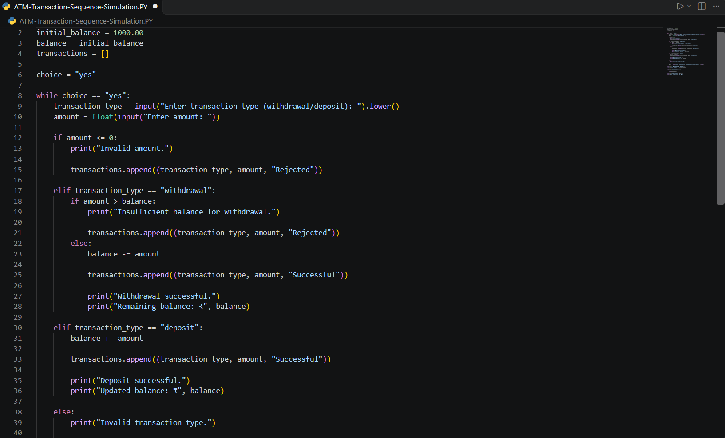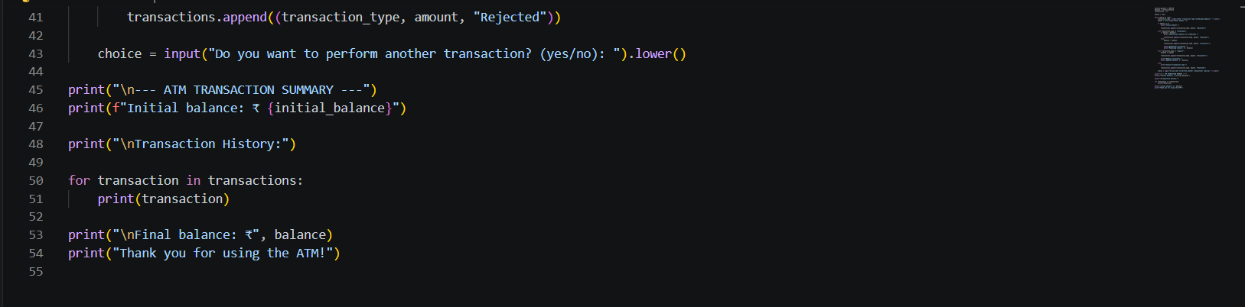

7. Test Cases
s.no | Transaction | Input amount | Expected result
1 | Withdrawal | 200 | Successful; balance becomes ₹800
2 | Deposit | 500 | Successful; balance becomes ₹1,300
3 | Withdrawal | 5000 | Rejected; insufficient balance
4 | Deposit | 0 | Rejected; invalid amount
5 | Invalid type | 100 | Rejected; invalid transaction type

8. Output Screenshots
Screenshot 1: Successful Deposit and Withdrawal Transactions
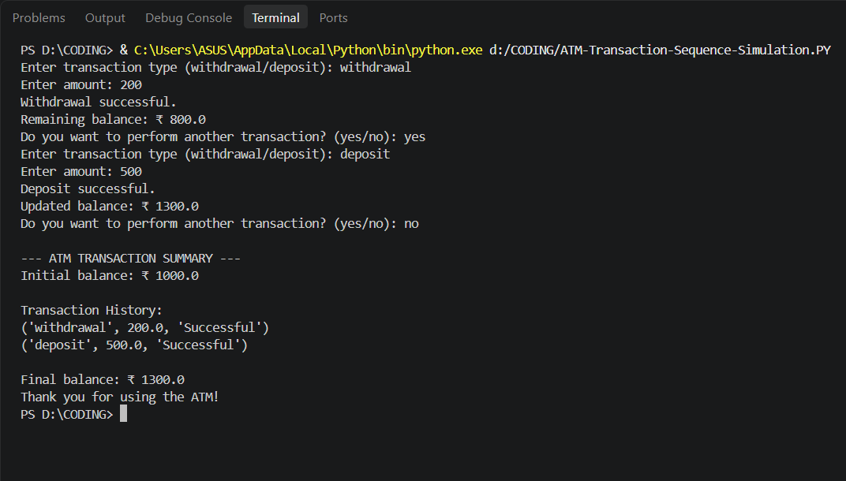
Screenshot 2: Rejected Transactions
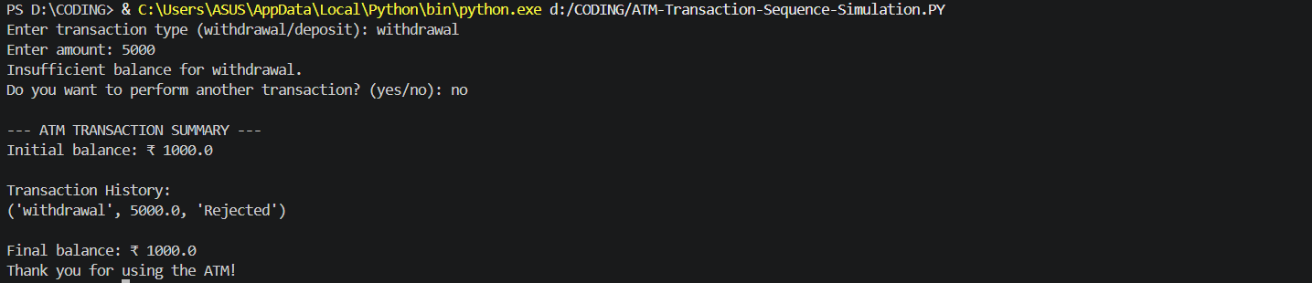
9. Conclusion
The ATM Transaction Sequence Simulation was successfully developed using Python. The program performs deposits and withdrawals, maintains the account balance, validates transaction amounts, and rejects invalid transactions and withdrawals when sufficient funds are not available. It also supports multiple transactions in a single session and stores transaction details in a list. Finally, the program displays the transaction history along with the initial and final balances. This project helped in understanding Python concepts such as variables, conditional statements, loops, lists, tuples, and user input.

